**DAY7 NAME: VINODHAN M**

**ROLL NO: 727721eucs180**

**CLASS EXERCISE 1 :** 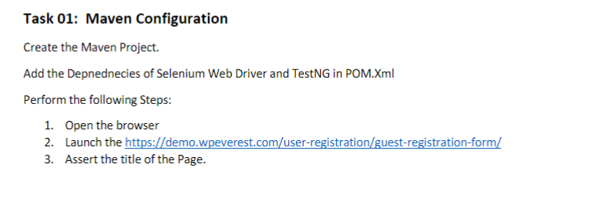

**CODE:**

package com.day6;

import org.testng.annotations.Test;

import io.github.bonigarcia.wdm.WebDriverManager;

import org.testng.annotations.BeforeMethod;

import org.openqa.selenium.WebDriver;

import org.openqa.selenium.chrome.ChromeDriver;

import org.openqa.selenium.chrome.ChromeOptions;

import org.testng.Assert;

import org.testng.annotations.AfterMethod;

public class CE_1 {

WebDriver driver; //declared here

@Test //defining execution

public void checkTitle()

{

driver.get("https://demo.wpeverest.com/user-registration/guest-registration-form/");

driver.manage().window().maximize();

String expectedTitle = "Guest Registration Form – User Registration";

String actualTitle = driver.getTitle();

System.out.println(expectedTitle);

System.out.println(actualTitle);

Assert.assertEquals(actualTitle,expectedTitle);

}

@BeforeMethod //before @Test this runs

public void beforeMethod()

{

ChromeOptions co = new ChromeOptions();

co.addArguments("--remote-allows-origins=*");

WebDriverManager.chromedriver().setup();

driver = new ChromeDriver();

}

@AfterMethod

public void afterMethod()

{

driver.close(); //close the browser when entire testcase is ran

}

}

**OUTPUT :**

}

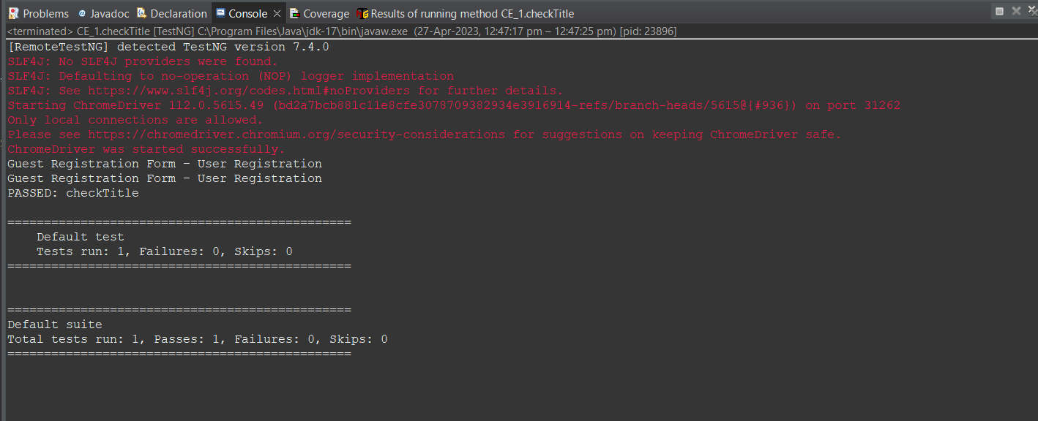

**CLASS EXERCISE 2 :** 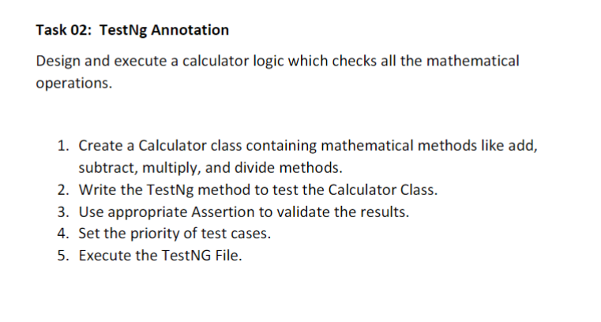**CODE :**

package com.day6;

import org.testng.annotations.Test;

import org.testng.annotations.BeforeMethod;

import org.testng.Assert;

import org.testng.annotations.AfterMethod;

public class CE_2_Calculator {

@Test(priority=2)

public void add()

{

int a=10,b=20,res=0;

res=a+b;

System.out.println(res);

Assert.assertEquals(res, 30);

}

@Test(priority=1)

public void sub()

{

int a =90,b=100,res;

res=b-a;

System.out.println(res);

Assert.assertEquals(res, 10);

}

@Test(priority=3)

public void mul()

{

int a =9,b=100,res;

res=b*a;

System.out.println(res);

Assert.assertEquals(res, 900);

}

@Test(priority=4)

public void div()

{

int a =10,b=100,res;

res=b/a;

System.out.println(res);

Assert.assertEquals(res, 10);

}

@BeforeMethod

public void beforeMethod() {

}

@AfterMethod

public void afterMethod() {

}

}

**OUTPUT :**

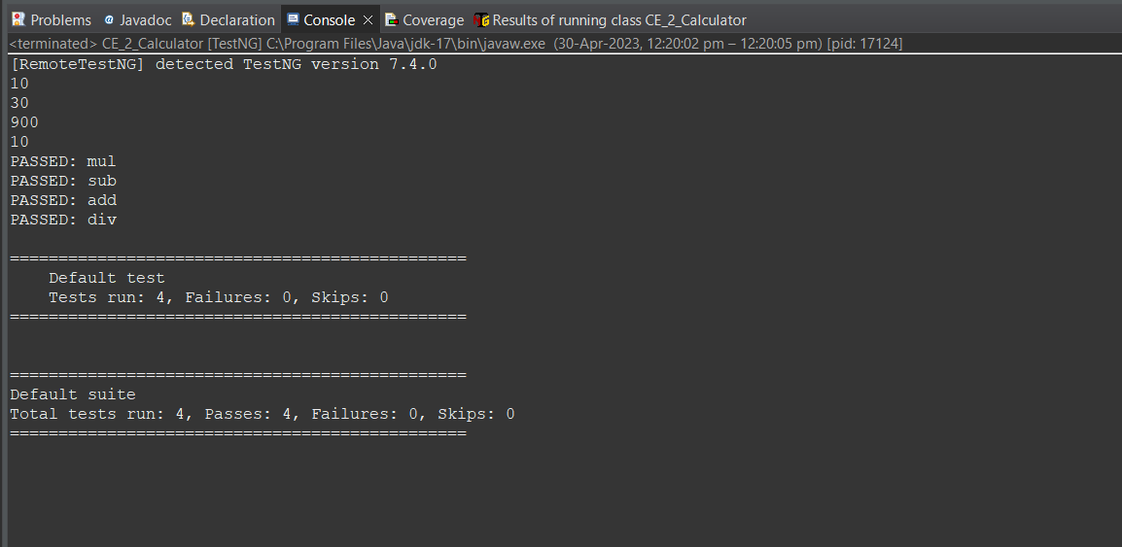

**CLASS EXERCISE 3 :** 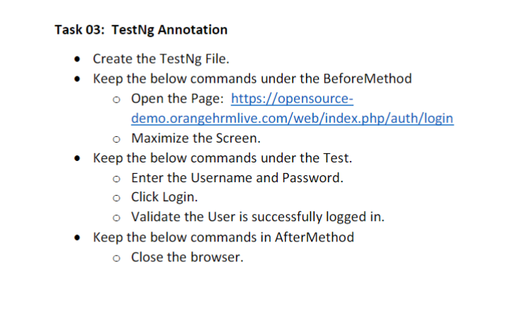

**CODE :**

package com.day6;

import org.testng.annotations.Test;

import io.github.bonigarcia.wdm.WebDriverManager;

import org.testng.annotations.BeforeMethod;

import org.openqa.selenium.By;

import org.openqa.selenium.Keys;

import org.openqa.selenium.WebDriver;

import org.openqa.selenium.WebElement;

import org.openqa.selenium.chrome.ChromeDriver;

import org.openqa.selenium.chrome.ChromeOptions;

import org.testng.Assert;

import org.testng.annotations.AfterMethod;

public class CE_3 {

WebDriver driver;

@Test

public void fillDetails() throws InterruptedException

{

Thread.sleep(3000);

WebElement userName = driver.findElement(By.xpath("/html/body/div/div[1]/div/div[1]/div/div[2]/div[2]/form/div[1]/div/div[2]/input"));

userName.sendKeys("Admin",Keys.ENTER);

WebElement passWord = driver.findElement(By.xpath("/html/body/div/div[1]/div/div[1]/div/div[2]/div[2]/form/div[2]/div/div[2]/input"));

passWord.sendKeys("admin123"); //Key.ENTER here automatically goes to next page..so here Keys.ENTER not given

driver.findElement(By.xpath("/html/body/div/div[1]/div/div[1]/div/div[2]/div[2]/form/div[3]/button")).click();

Thread.sleep(3000);

String validate = driver.findElement(By.xpath("/html/body/div/div[1]/div[1]/header/div[1]/div[1]/span/h6")).getText();

Assert.assertEquals(validate, "Dashboard");

}

@BeforeMethod

public void beforeMethod()

{

ChromeOptions co = new ChromeOptions();

co.addArguments("--remote-allows-origins=*");

WebDriverManager.chromedriver().setup();

driver = new ChromeDriver();

driver.get("https://opensource-demo.orangehrmlive.com/web/index.php/auth/login");

driver.manage().window().maximize();

}

@AfterMethod

public void afterMethod()

{

driver.close();

}

}

**OUTPUT :**

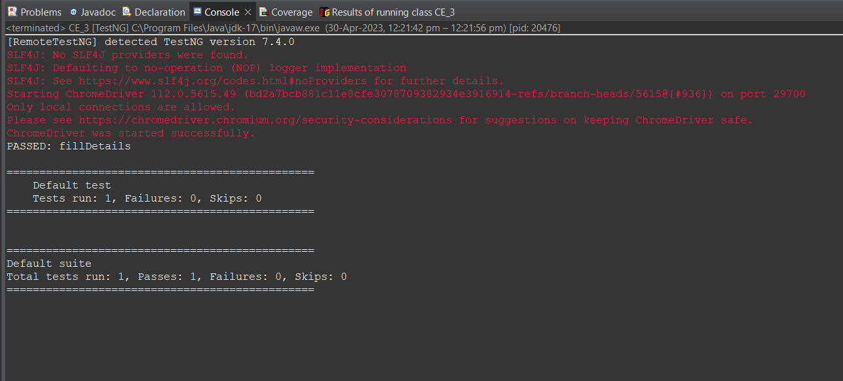

**CLASS EXERCISE 4 :**

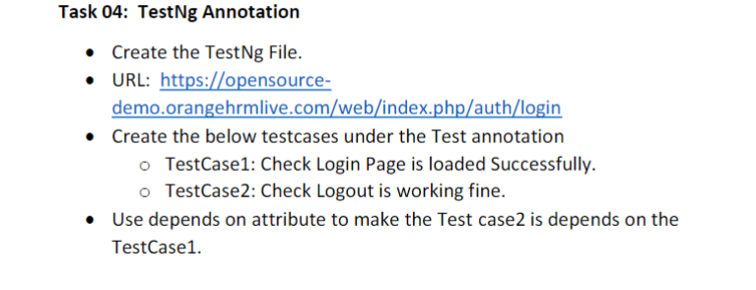

**CODE :**

package com.day6;

import org.testng.annotations.Test;

import io.github.bonigarcia.wdm.WebDriverManager;

import org.testng.annotations.BeforeClass;

import org.openqa.selenium.By;

import org.openqa.selenium.Keys;

import org.openqa.selenium.WebDriver;

import org.openqa.selenium.WebElement;

import org.openqa.selenium.chrome.ChromeDriver;

import org.openqa.selenium.chrome.ChromeOptions;

import org.testng.Assert;

import org.testng.annotations.AfterClass;

public class CE__4 {

WebDriver driver;

@Test

public void login() throws InterruptedException {

Thread.sleep(3000);

WebElement userName = driver.findElement(By.xpath("/html/body/div/div[1]/div/div[1]/div/div[2]/div[2]/form/div[1]/div/div[2]/input"));

userName.sendKeys("Admin",Keys.ENTER);

WebElement passWord = driver.findElement(By.xpath("/html/body/div/div[1]/div/div[1]/div/div[2]/div[2]/form/div[2]/div/div[2]/input"));

passWord.sendKeys("admin123"); driver.findElement(By.xpath("/html/body/div/div[1]/div/div[1]/div/div[2]/div[2]/form/div[3]/button")).click();

Thread.sleep(3000);

String validate = driver.findElement(By.xpath("/html/body/div/div[1]/div[1]/header/div[1]/div[1]/span/h6")).getText();

Assert.assertEquals(validate, "Dashboard");

System.out.println("Successfull Login");

}

@Test(dependsOnMethods="login")

public void logout() throws InterruptedException

{

WebElement l = driver.findElement(By.xpath("/html/body/div/div[1]/div[1]/header/div[1]/div[2]/ul/li/span/i"));

l.click();

driver.findElement(By.xpath("/html/body/div/div[1]/div[1]/header/div[1]/div[2]/ul/li/ul/li[4]/a")).click();

Thread.sleep(3000);

String out = driver.findElement(By.xpath("/html/body/div/div[1]/div/div[1]/div/div[2]/h5")).getText();

Assert.assertEquals(out,"Login");

System.out.println("Successfull Logout");

}

@BeforeClass

public void beforeClass() {

ChromeOptions co = new ChromeOptions();

co.addArguments("--remote-allows-origins=*");

WebDriverManager.chromedriver().setup();

driver = new ChromeDriver();

driver.get("https://opensource-demo.orangehrmlive.com/web/index.php/auth/login");

driver.manage().window().maximize();

}

@AfterClass

public void afterClass() {

driver.close();

}

}

**OUTPUT :** 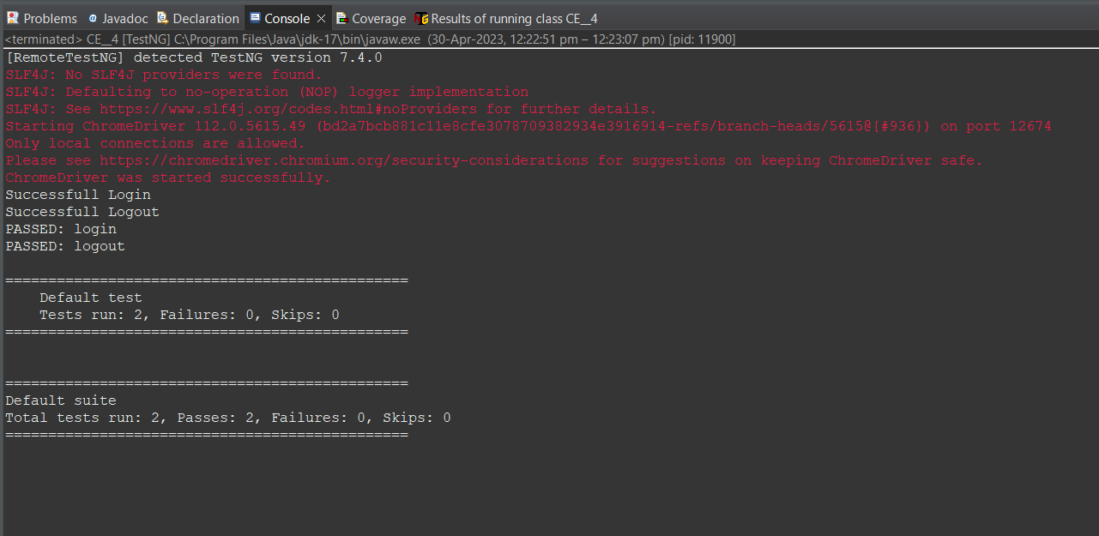

**CLASS EXERCISE 5 :** 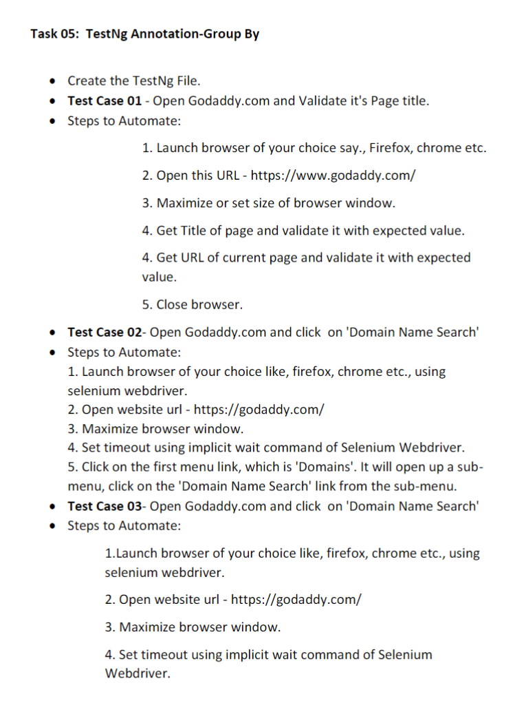

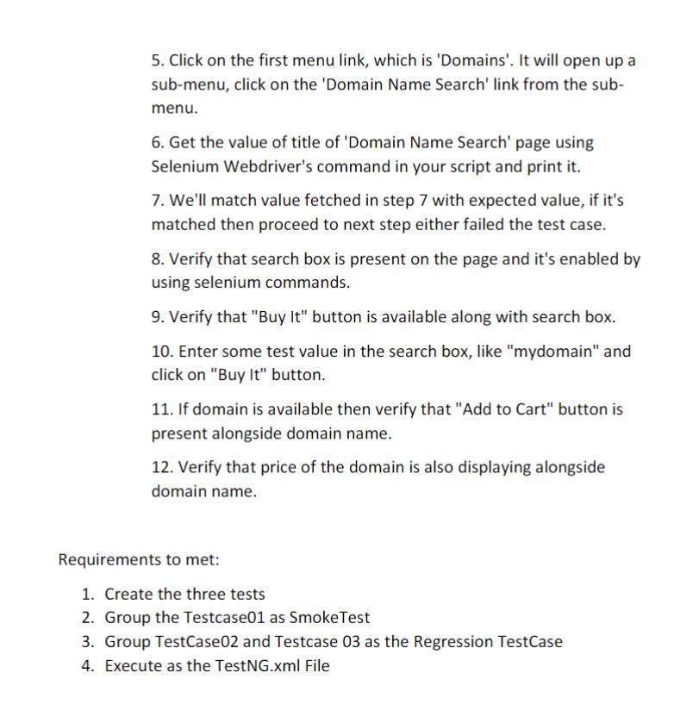

**CODE :**

package com.day6;

import org.testng.annotations.Test;

import io.github.bonigarcia.wdm.WebDriverManager;

import org.testng.annotations.BeforeMethod;

import java.util.concurrent.TimeUnit;

import org.openqa.selenium.By;

import org.openqa.selenium.WebDriver;

import org.openqa.selenium.WebElement;

import org.openqa.selenium.chrome.ChromeDriver;

import org.openqa.selenium.chrome.ChromeOptions;

import org.testng.Assert;

import org.testng.annotations.AfterMethod;

public class CE_5 {

WebDriver driver;

@Test(groups="SmokeTest")

public void validate() {

ChromeOptions co = new ChromeOptions();

co.addArguments("--remote-allows-origins=*");

WebDriverManager.chromedriver().setup();

driver = new ChromeDriver(co);

driver.get("https://www.godaddy.com/");

driver.manage().window().maximize();

String actualTitle = driver.getTitle();

String expectedTitle = "Domain Names, Websites, Hosting & Online Marketing Tools - GoDaddy IN";

Assert.assertEquals(actualTitle, expectedTitle);

String actualUrl = driver.getCurrentUrl();

String expectedUrl = "https://www.godaddy.com/en-in";

Assert.assertEquals(actualUrl, expectedUrl);

}

@Test(groups="RegressionTestCase")

public void search() throws InterruptedException

{

ChromeOptions co = new ChromeOptions();

co.addArguments("--remote-allows-origins=*");

WebDriverManager.chromedriver().setup();

driver = new ChromeDriver(co);

driver.get("https://www.godaddy.com/");

driver.manage().window().maximize();

Thread.sleep(3000);

driver.findElement(By.xpath("/html/body/header/div/section/div/div[1]/nav/div[2]/div[1]/ul/li[1]/button")).click();

Thread.sleep(3000);

driver.findElement(By.linkText("Domain Name Search")).click();;

}

@Test(groups="RegressionTestCase")

public void case3() throws InterruptedException

{

ChromeOptions co = new ChromeOptions();

co.addArguments("--remote-allows-origins=*");

WebDriverManager.chromedriver().setup();

driver = new ChromeDriver(co);

driver.get("https://www.godaddy.com/");

driver.manage().window().maximize();

Thread.sleep(3000);

driver.findElement(By.xpath("/html/body/header/div/section/div/div[1]/nav/div[2]/div[1]/ul/li[1]/button")).click();

Thread.sleep(3000);

driver.findElement(By.linkText("Domain Name Search")).click();

Thread.sleep(3000);

String title = driver.getTitle();

System.out.println(title);

Assert.assertEquals(title, "GoDaddy Domain Search - Buy and Register Available Domain Names");

Thread.sleep(5000);

boolean isSearchBoxPresent = driver.findElement(By.name("searchText")).isDisplayed();

Assert.assertEquals(isSearchBoxPresent, true);

}

@BeforeMethod

public void beforeMethod() throws InterruptedException {

//group panrapo thani thaniya pannu.....

}

@AfterMethod

public void afterMethod() {

driver.close();

}

}

**OUTPUT :**

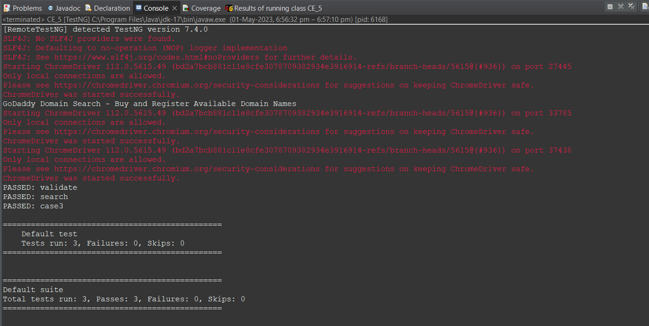

**CODE** **(tetsng.xml) :**

<?xml version="1.0" encoding="UTF-8"?>

<!DOCTYPE suite SYSTEM "https://testng.org/testng-1.0.dtd">

<suite name="Suite">

<groups>

<run>

<include name="RegressionTestCase"></include>

</run>

</groups>

<test thread-count="5" name="Test">

<classes>

<class name="com.day6.CE_3"/>

<class name="com.day6.CE_2_Calculator"/>

<class name="com.day6.CE_1"/>

<class name="com.day6.CE__4"/>

<class name="com.day6.CE_5"/>

</classes>

</test> <!-- Test -->

</suite> <!-- Suite -->

**OUTPUT :**

